

By signing this form, you give permission for your images taken to be used in communications materials which promote or advertise the work of Surfers Against Sewage. This could be in any printed or digital format including, but not limited to; social media platforms, press and other publications, adverts, reports, resources, display materials and any other media we may use in the future.

On occasion, we may also supply images to partners, third party publications and websites to support articles relating to our work.

You may withdraw this permission at any time by writing to us at: Surfers Against Sewage, Wheal Kitty Workshops, St Agnes, TR15 0RD.

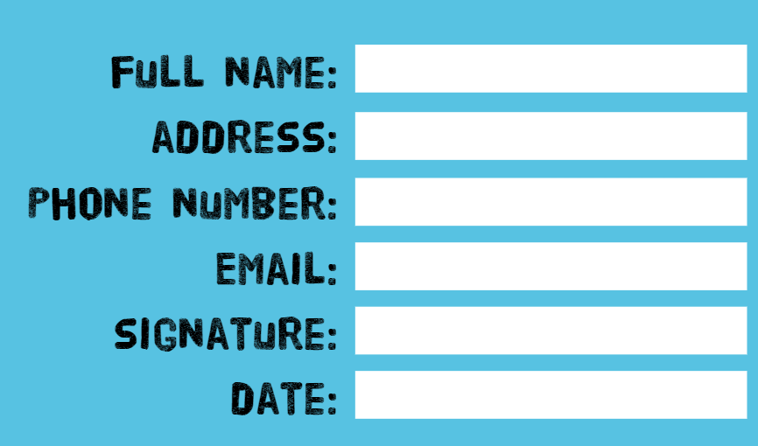The copyright of any material which is generated as a result of this photographic session shall be the property of Surfers Against Sewage.